# **AWS ECS on EC2 vs Fargate**

ECS stands for Elastic Container Service

Different ways to run docker images on EC2 are as below:

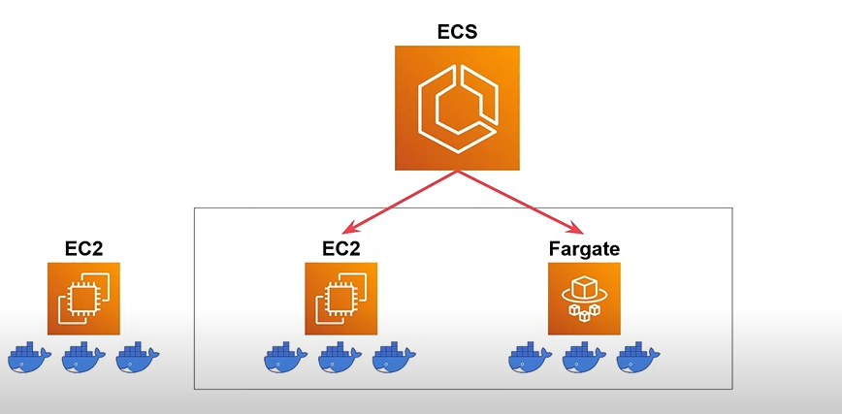

ECS key terms are as below:

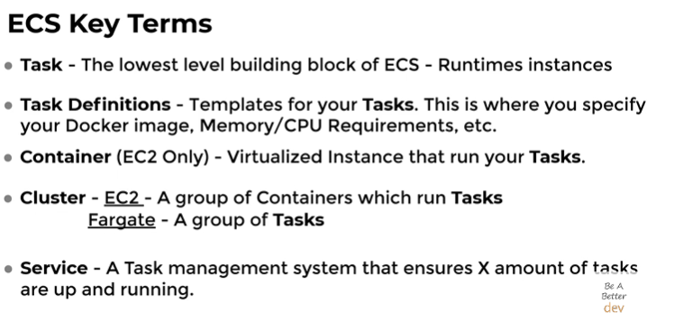

Architectural Differences between ECS on EC2 vs Fargate launch types:

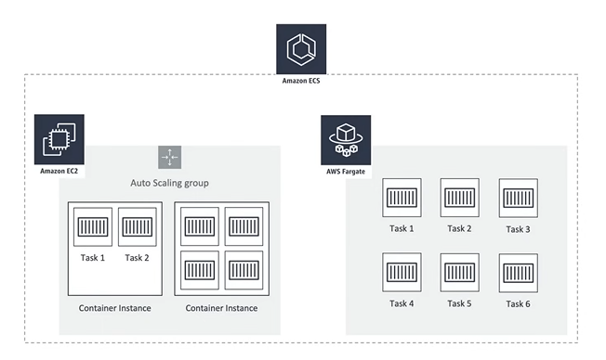

When to use What?

